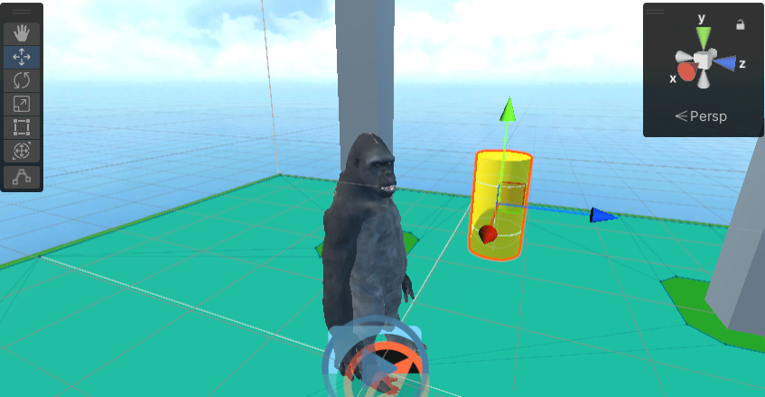

Imported a Gorilla model from the Character Creator program and set it up for Unity. Added idle and jump animation, which are triggered by an Object with tag "Banana". Implemented AI navigation for roaming to random positions on a surface, and head tracking of a banana object.

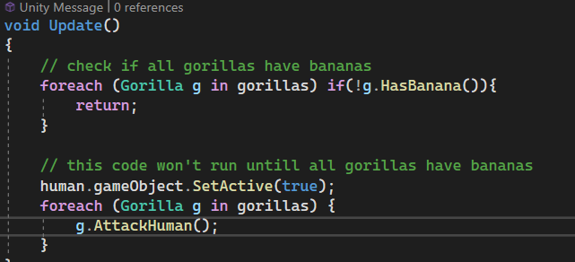

Gorilla Manager script that checks if all gorillas have a banana.

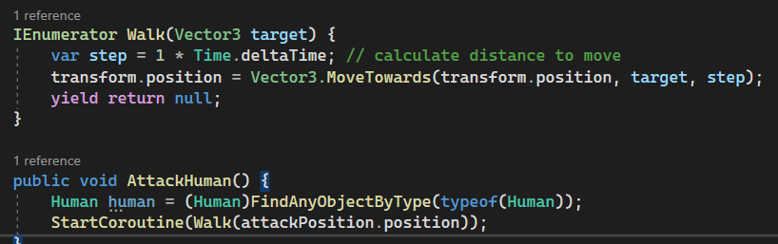

Used a coroutine to make the gorilla move to a certain position when the human enters the scene.

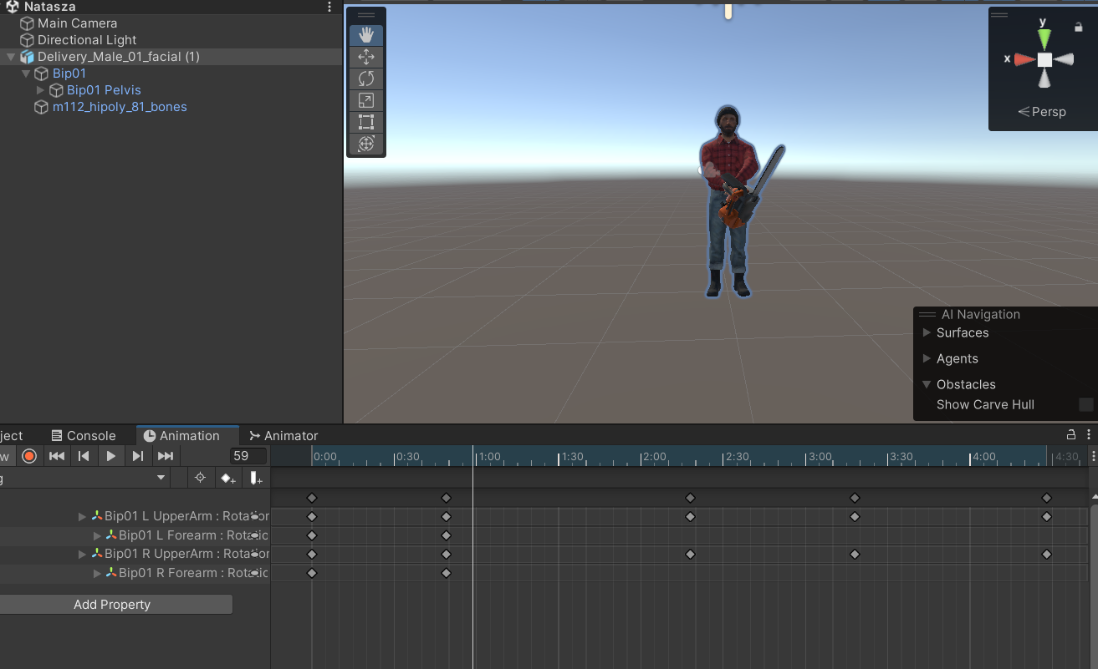

4 Created a new scene, imported character and added customised animation, so the character looks like he’s cutting the trees.

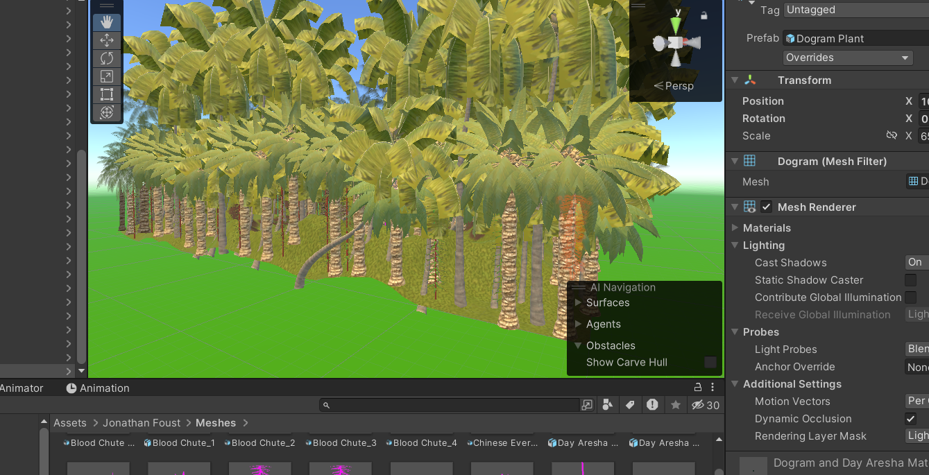

5 Added new scene called “Rainforest”, downloaded assets such as Palm Trees, plants and terrain.

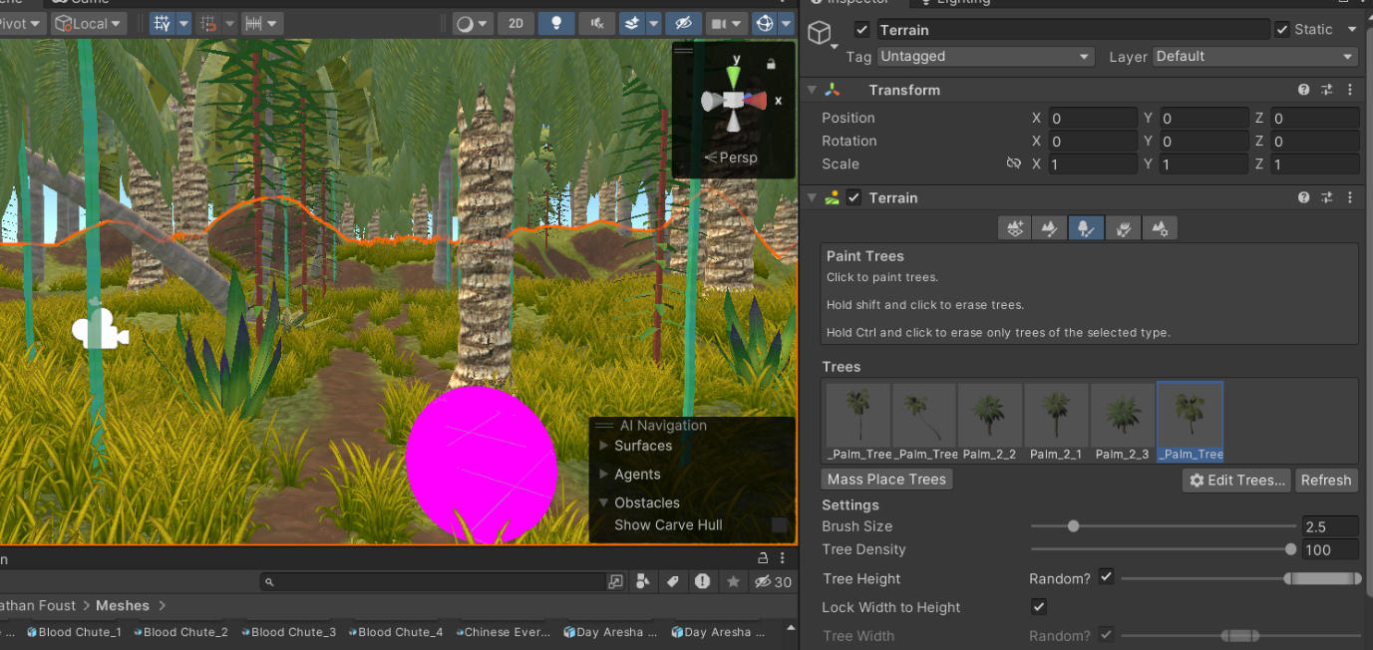  
6. Added Palm trees to the terrain using a brush in the inspector window.

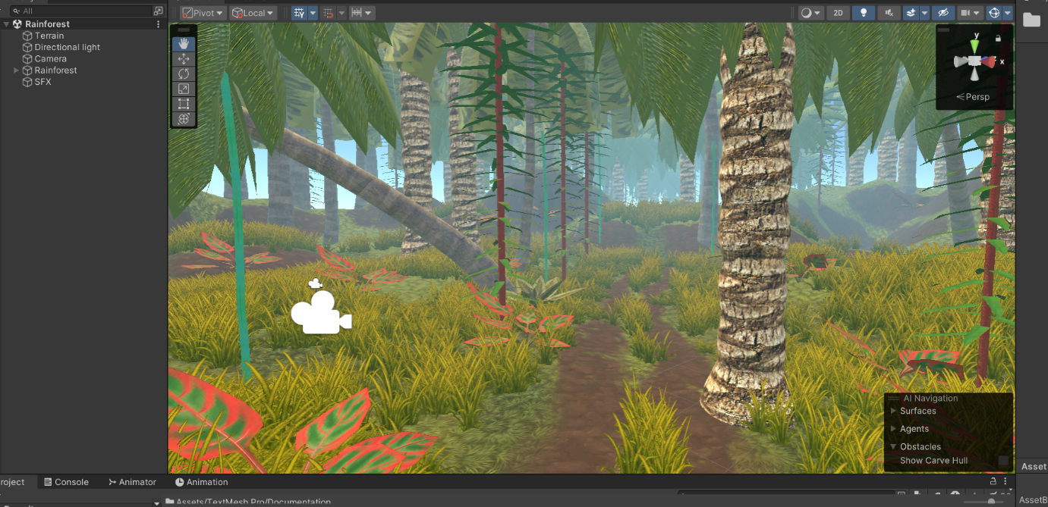

5. Added details, such as fog, small jungle plants and sound effects.

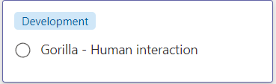

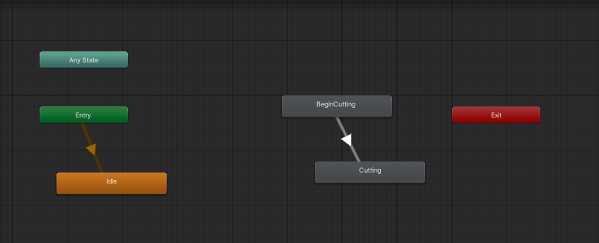

Adjusted animations for looping and AI Navigation

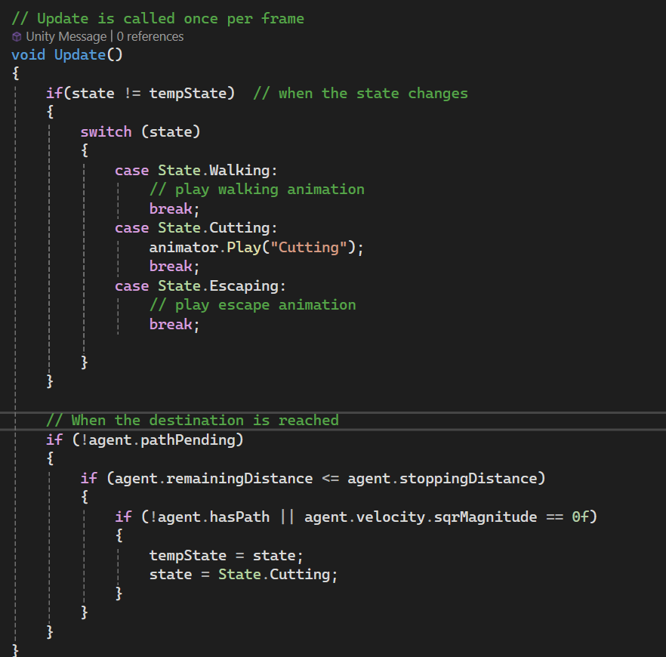

State switching for Human.

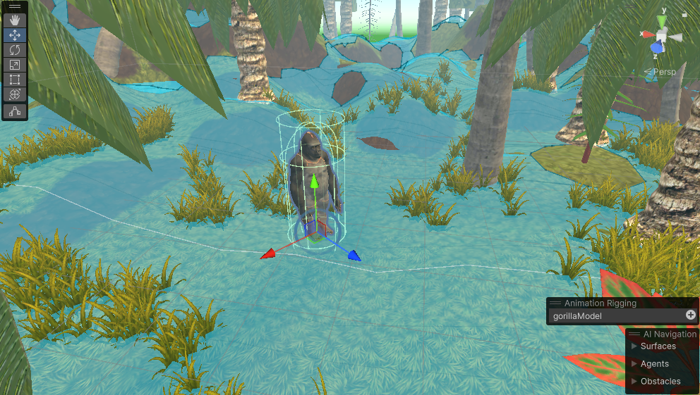

Shifted implemented assets into a new scene with the built environment.

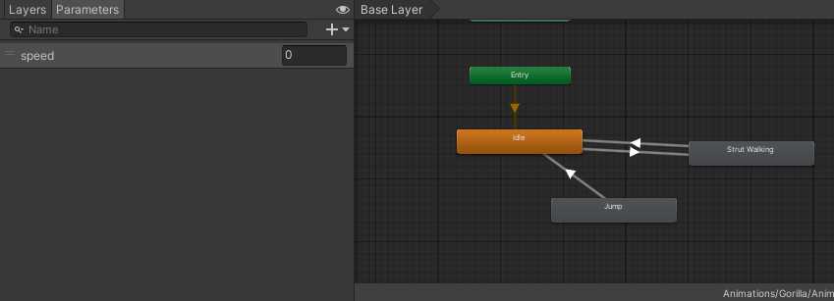

Set parameter-based transitions between the walking and idle states. The speed parameter monitors the movement of the navmesh agent.

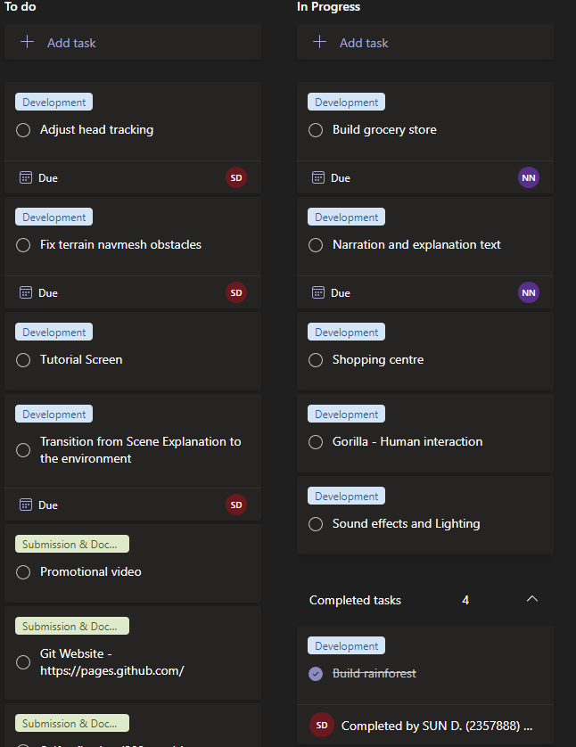

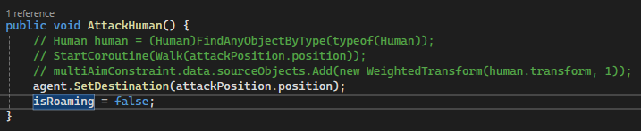

Changed the gorilla movement with predetermined destination to a simpler method. Set up a first working environment where two gorillas can receive bananas, hold them in their hand and wait until both receive bananas to simultaneously move to a location. The human starts to approach a tree at this time. The performance of the environment is acceptable although it could be improved (dips of <15fps (with realtime lighting) ).

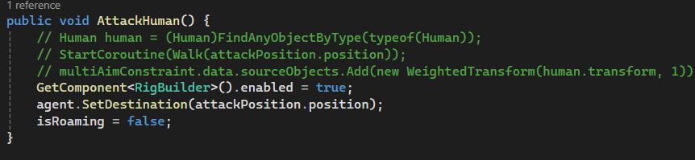

Gorillas face the human when they go in "attack mode"

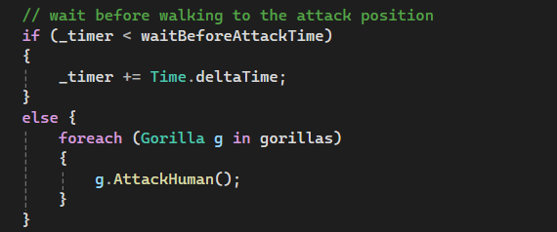

Implemented a timer between the collection of all bananas and the movement towards the human.

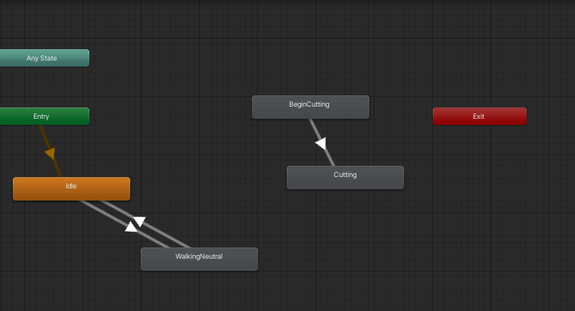

Added walking animation to human.

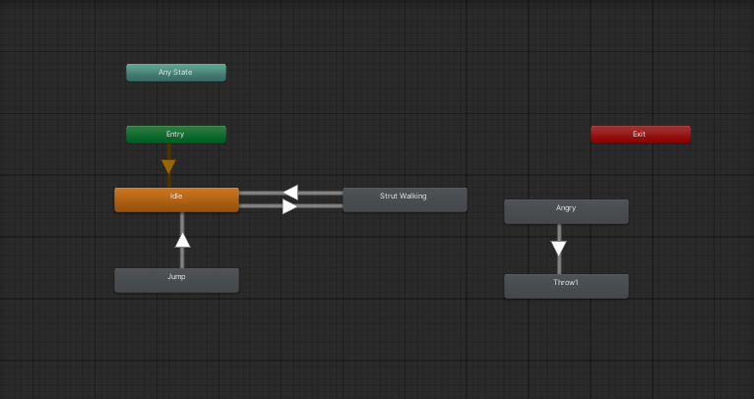

Gorilla animator updated with throwing bananas animations.

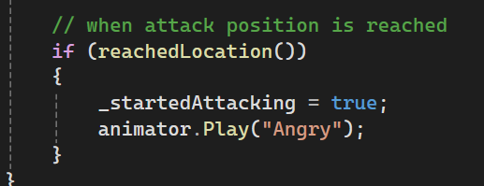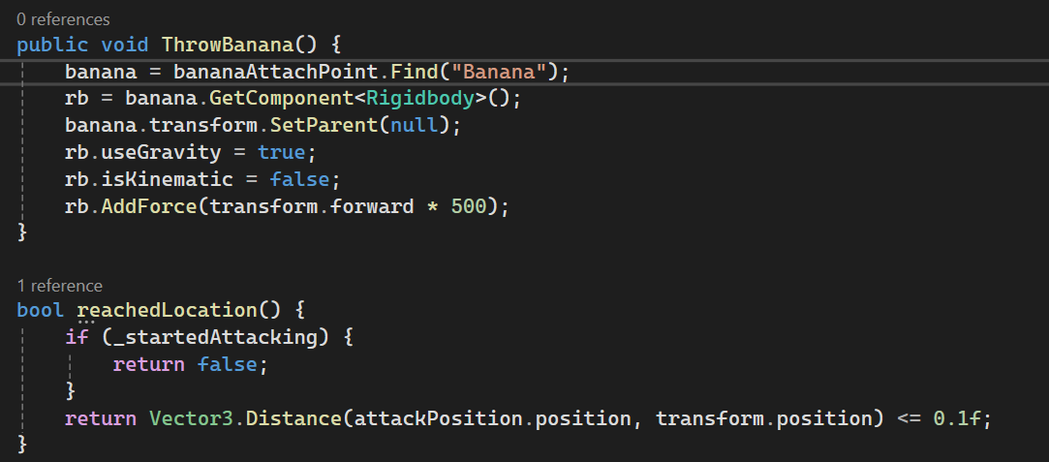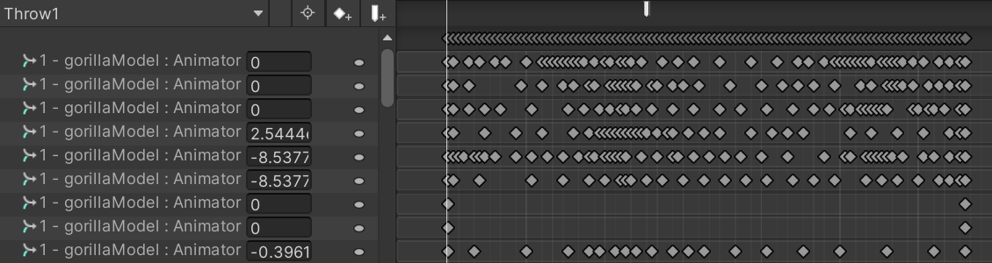

Throwing effect is implemented using an animation event that uses the method "ThrowBanana". This detaches the banana object from its parent and adds a force to the rigidbody sending it forward.

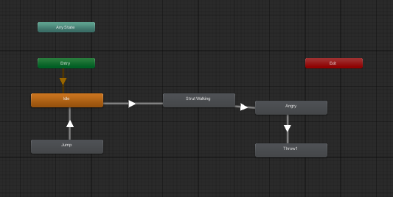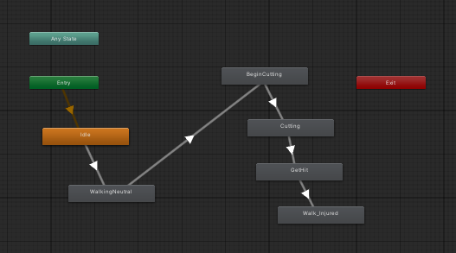

Changed the animations controllers to allow smooth transitioning from one stage of the animation to the next.

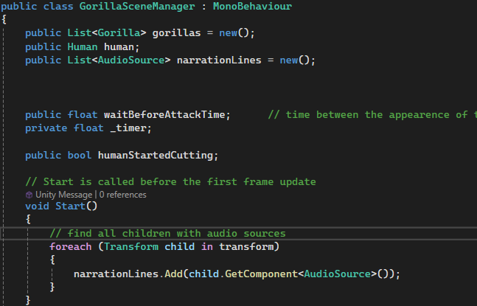

Inserted narration lines as children of the scene manager object that can be played during the scene.

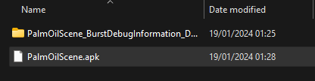

First test build. Some performance issues need to be fixed.

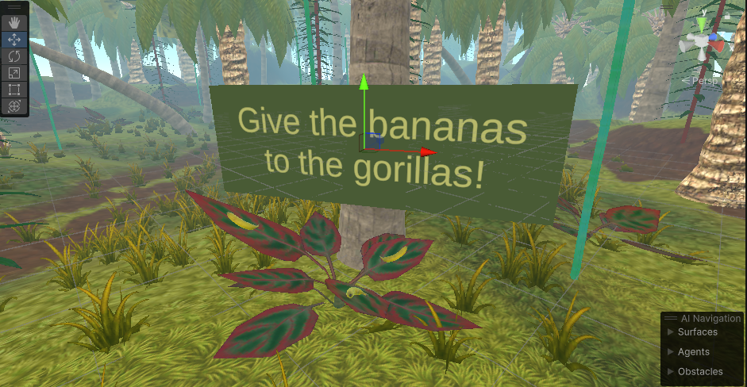

Created a script to allow bananas that fall out of bounds to respawn. Created a tooltip to make players give the bananas to the gorillas.

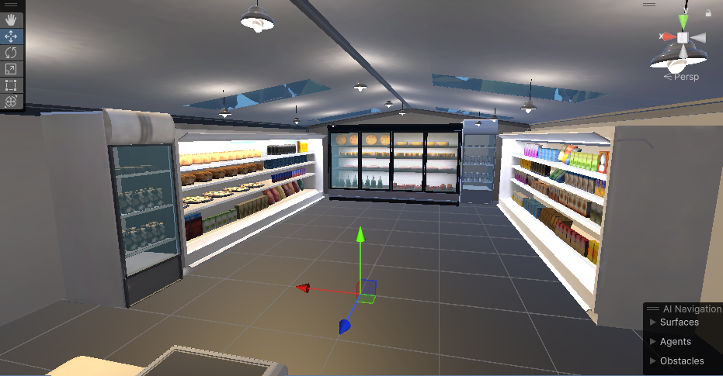

Finished setting up grocery store scene.

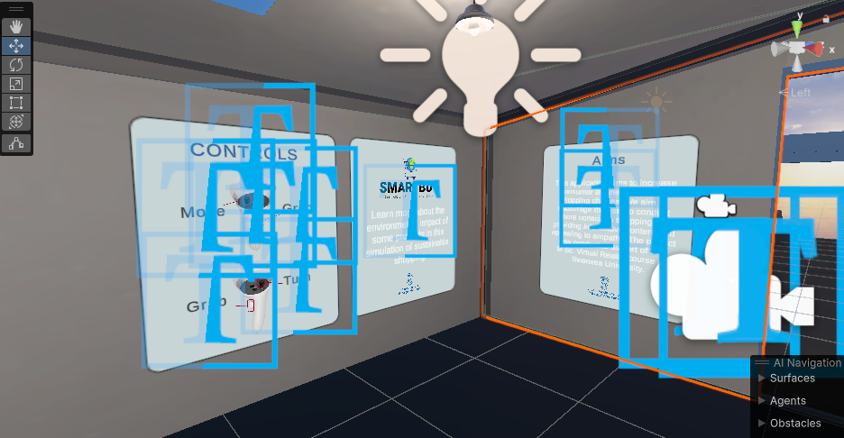

Created introduction panels at the beginning of the app.

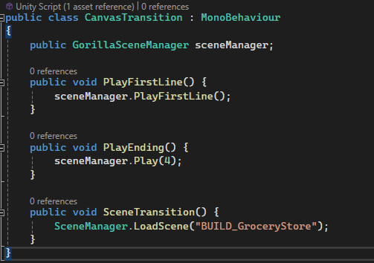

Script to manage the transition effects in the Rainforest.

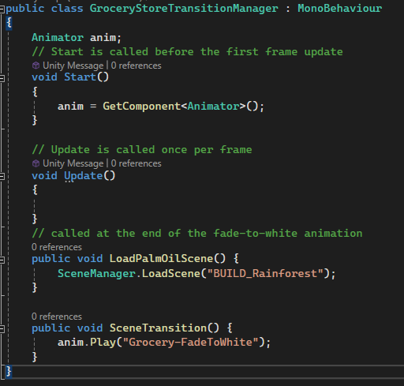

Script to manage the transition effects in the grocery store.